**Task Performance**

Mobile Login Interface:

Know the User

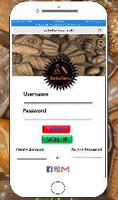This is important now because everyone is using a cellphone. It's easy to hold, use, and convenient for us to do our task. If you don't have a laptop, or computer you can still do what you need to do.

In general computer usage, login is the procedure used to get access to an operating system or application, usually in a remote computer. Almost always a login requires that the user have (1) a user ID and (2) a password. Often, the user ID must conform to a limited length such as eight [character](https://whatis.techtarget.com/definition/character)s and the password must contain at least one digit and not match a natural language word. The user ID can be freely known and is visible when entered at a keyboard or other input device. The password must be kept secret (and is not displayed as it is entered). Some Web sites require users to register in order to use the site; registered users can then enter the site by logging on.

Understand the Task

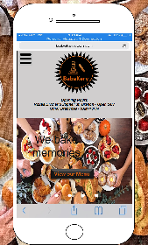Homepage

Your first thought might be “My homepage makes a first impression for visitors”. Yes, there was a time, not too long ago, when a company’s homepage was considered the most important page on their website. This is no longer the case. Content is a key. Today, the old methods of disruptive advertising and cold homepages simply don’t work. You have to earn users attention and provide something valuable for your visitors — not just say common sentences like “We serve” or “Buy it”. And yes, this rule works for your company’s homepage too. After all, content is king. Understand the goal of your content and plan accordingly. If it’s good for users, you should make it good for business. Measure. Use metrics to understand what content is the most interested for users. Only after that you will be able to see what actually retains your users’ attention. Your homepage isn’t the place to talk about you at all — homepage is the place to talk about your customers. Highlight the primary message so it embraces users needs and interests, and clearly communicates how your product or service will improve their lives or help to solve their problems.

Reduce Memory Load

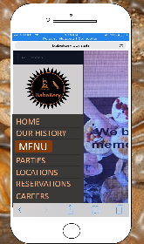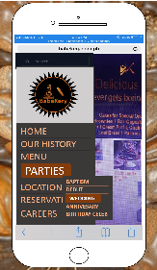When designing a usable UI we must consider the context in which the interface will be used. For mobile design in particular, users often hold their device in one hand while doing other activities—watching television, walking, or even driving. In such circumstances it can be daunting to tap and drag a control precisely to a particular spot.Use a label bars only when the precise valu e won’t matter to the user, but rather only the approximate range. Make sure that the users can select that range correctly without having to struggle too much to hit a precise value. In addition, any bars label must be displayed above or beside the bar, rather than below it, in order to remain visible while the user is selecting a value. Alternatively, consider a different UI element that allows users to tap or even type to specify their choice rather than relying on press-and-drag gestures.

Remind user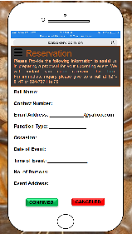/ Prevent Errors/ Reversal Action

Apart from facilitating an online order, you need to integrate the table reservation feature to enrich the user experience. Your app can show the schematic illustrations of both vacant and booked tables to assist your customers to decide the table as per their choice. When booking a reservation the customer should be clear about whether they are still available or not, if there is a problem with location, time,etc.

Natural Interaction and Interface

The 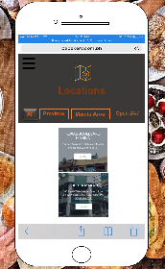location is important it gives customers a true sense of your business. And this is for natural interaction and interface between the employees or the owner and the customers.

Strive for Consistency

Consistency in UI design is concerned with making sure elements in a user interface are uniform. They’ll look and behave the same way. This helps constantly prove a user’s assumptions about the user interface right, creating a sense of control, familiarity, and reliability.To develop consistency in UI design, you should aim to be consistent with device UI guidelines and behaviors, other similar apps/sites, and with your own design.